1. **Logical data model: Database Design Diagram**

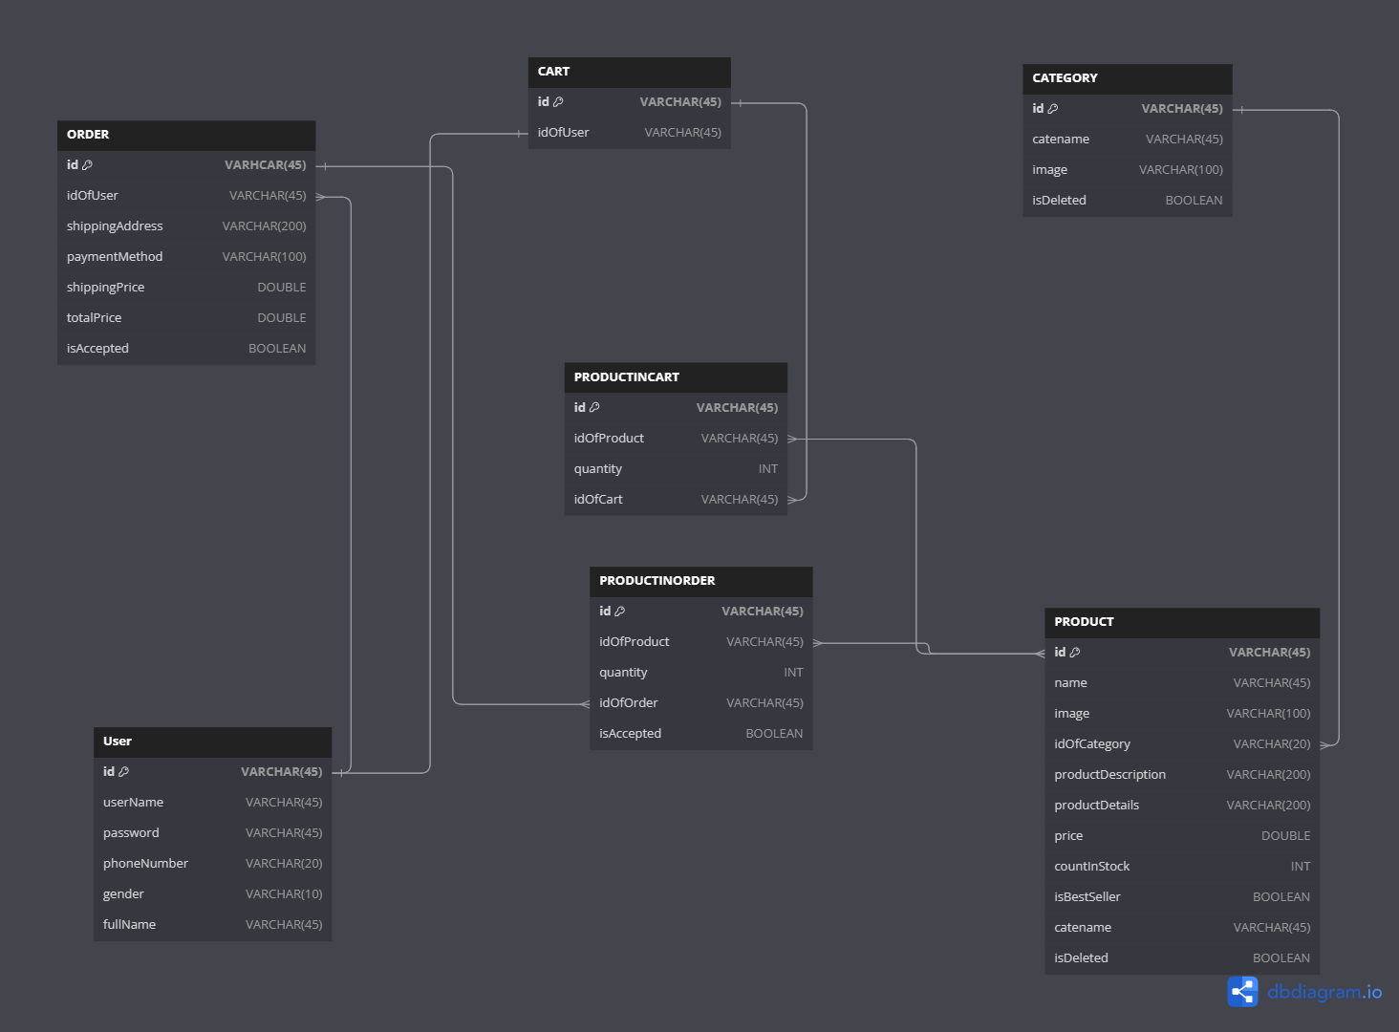

1. **Physical data model:**
   1. **Table ORDER**

|  |  |  |  |  |  |  |
| --- | --- | --- | --- | --- | --- | --- |
| **STT** | **PK** | **FK** | **Column Name** | **Data Type** | **Mandatory** | **Description** |
| **1** | x |  | id | VARCHAR(45) | Yes | ID |
| **2** |  |  | idOfUser | VARCHAR(45) | Yes | Id of user |
| **3** |  |  | shippingAddress | VARCHAR(200) | Yes | Shipping Address |
| **4** |  |  | paymentMethod | VARCHAR(100) | Yes | Payment Method |
| **5** |  |  | shippingPrice | DOUBLE | Yes | Shipping Price |
| **6** |  |  | totalPrice | DOUBLE | Yes | Total Price |
| **7** |  |  | isAccepted | BOOLEAN | NO |  |

* 1. **Table Cart**

|  |  |  |  |  |  |  |
| --- | --- | --- | --- | --- | --- | --- |
| **STT** | **PK** | **FK** | **Column Name** | **Data Type** | **Mandatory** | **Description** |
| **1** | x |  | id | VARCHAR(45) | YES | Id |
| **2** |  |  | idOfUser | VARCHAR(45) | YES | ID of user |

* 1. **Table CATEGORY**

|  |  |  |  |  |  |  |
| --- | --- | --- | --- | --- | --- | --- |
| **STT** | **PK** | **FK** | **Column Name** | **Data Type** | **Mandatory** | **Description** |
| **1** | x |  | id | VARCHAR(45) | YES | Id |
| **2** |  |  | cateName | VARCHAR(45) | YES | Cate name |
| **3** |  |  | image | VARCHAR(100) | YES | Image |
| **4** |  |  | isDeleted | BOOLEAN |  | Category is deleted |

* 1. **Table PRODUCTINCART**

|  |  |  |  |  |  |  |
| --- | --- | --- | --- | --- | --- | --- |
| **STT** | **PK** | **FK** | **Column Name** | **Data Type** | **Mandatory** | **Description** |
| **1** | X |  | id | VARCHAR(45) | Yes | Id |
| **2** |  |  | idOfProduct | VARCHAR(45) | Yes | Id Of Product |
| **3** |  |  | quantity | INT | YES | Quantity |
| **4** |  |  | idOfCart | VARCHAR(45) | YES | Id of Cart |

* 1. **Table PRODUCTINORDER**

|  |  |  |  |  |  |  |
| --- | --- | --- | --- | --- | --- | --- |
| **STT** | **PK** | **FK** | **Column Name** | **Data Type** | **Mandatory** | **Description** |
| **1** | x |  | id | INT | Yes | ID |
| **2** |  |  | idOfProduct | VARCHAR(45) | Yes | Id of product |
| **3** |  |  | quantity | INT | Yes | Quantity |
| **4** |  |  | idOfOrder | VARCHAR(45) | Yes | Id of Order |
| **5** |  |  | isAccepted | BOOLEAN |  |  |

* 1. **Table USER**

|  |  |  |  |  |  |  |
| --- | --- | --- | --- | --- | --- | --- |
| **STT** | **PK** | **FK** | **Column Name** | **Data Type** | **Mandatory** | **Description** |
| **1** | x |  | id | INT | Yes | ID, |
| **2** |  |  | userName | VARCHAR(45) | Yes | User Name |
| **3** |  |  | passWord | VARCHAR(45) | Yes | Pass word |
| **4** |  |  | phoneNumber | VARCHAR(20) | Yes | Phone number |
| **5** |  |  | gender | VARCHAR (10) | Yes | Gender |
| **6** |  |  | fullName | VARCHAR(45) | Yes | Full Name |
| **7** |  |  | role | VARCHAR (10) |  | Role |

* 1. **Table PRODUCT**

|  |  |  |  |  |  |  |
| --- | --- | --- | --- | --- | --- | --- |
| **STT** | **PK** | **FK** | **Column Name** | **Data Type** | **Mandatory** | **Description** |
| **1** | x |  | id | INT | Yes | ID |
| **2** |  |  | Name | VARCHAR(45) | Yes | Name of product |
| **3** |  |  | Image | VARCHAR(45) | Yes | Image link of product |
| **4** |  |  | idOfCategory | VARCHAR(45) | Yes | Id Of Category |
| **5** |  |  | productDescription | VARCHAR(200) | Yes | Product Description |
| **6** |  |  | ProductDetails | VARCHAR(200) | Yes | Product Details |
| **7** |  |  | Price | DOUBLE | Yes | Price Of Product |
| **8** |  |  | countInStock | INT | Yes | Count In Stock |
| **9** |  |  | isBestSeller | BOOLEAN | Yes | Is best seller product |
| **10** |  |  | Catename | VARCHAR(45) | Yes | Cate name |
| **11** |  |  | isDeleted | BOOLEAN |  | Product is deleted ? |

* **Database Script from Logical Data Model**

CREATE DATABASE `aims` /*!40100 DEFAULT CHARACTER SET utf8mb4 COLLATE utf8mb4_0900_ai_ci */ /*!80016 DEFAULT ENCRYPTION='N' */;

CREATE TABLE "PRODUCT" (

  "id" VARCHAR(45) PRIMARY KEY NOT NULL,

  "name" VARCHAR(45) NOT NULL,

  "image" VARCHAR(100) NOT NULL,

  "idOfCategory" VARCHAR(20) NOT NULL,

  "productDescription" VARCHAR(200) NOT NULL,

  "productDetails" VARCHAR(200) NOT NULL,

  "price" DOUBLE NOT NULL,

  "countInStock" INT NOT NULL,

  "isBestSeller" BOOLEAN NOT NULL,

  "catename" VARCHAR(45) NOT NULL,

  "isDeleted" BOOLEAN DEFAULT false

);

CREATE TABLE "CATEGORY" (

  "id" VARCHAR(45) PRIMARY KEY NOT NULL,

  "catename" VARCHAR(45) NOT NULL,

  "image" VARCHAR(100) NOT NULL,

  "isDeleted" BOOLEAN DEFAULT false

);

CREATE TABLE "ORDER" (

  "id" VARHCAR(45) PRIMARY KEY NOT NULL,

  "idOfUser" VARCHAR(45) NOT NULL,

  "shippingAddress" VARCHAR(200) NOT NULL,

  "paymentMethod" VARCHAR(100) NOT NULL,

  "shippingPrice" DOUBLE NOT NULL,

  "totalPrice" DOUBLE NOT NULL,

  "isAccepted" BOOLEAN DEFAULT true

);

CREATE TABLE "PRODUCTINORDER" (

  "id" VARCHAR(45) PRIMARY KEY NOT NULL,

  "idOfProduct" VARCHAR(45) NOT NULL,

  "quantity" INT NOT NULL,

  "idOfOrder" VARCHAR(45) NOT NULL,

  "isAccepted" BOOLEAN DEFAULT true

);

CREATE TABLE "CART" (

  "id" VARCHAR(45) PRIMARY KEY NOT NULL,

  "idOfUser" VARCHAR(45) NOT NULL

);

CREATE TABLE "PRODUCTINCART" (

  "id" VARCHAR(45) PRIMARY KEY NOT NULL,

  "idOfProduct" VARCHAR(45) NOT NULL,

  "quantity" INT NOT NULL,

  "idOfCart" VARCHAR(45) NOT NULL

);

CREATE TABLE "USER" (

  "id" VARCHAR(45) PRIMARY KEY NOT NULL,

  "userName" VARCHAR(45) NOT NULL,

  "password" VARCHAR(45) NOT NULL,

  "phoneNumber" VARCHAR(20) NOT NULL,

  "gender" VARCHAR(10) NOT NULL,

  "fullName" VARCHAR(45) NOT NULL

"role" VARCHAR(10)

);

ALTER TABLE "CART" ADD FOREIGN KEY ("idOfUser") REFERENCES "User" ("id");

ALTER TABLE "PRODUCT" ADD FOREIGN KEY ("idOfCategory") REFERENCES "CATEGORY" ("id");

CREATE TABLE "PRODUCTINCART_PRODUCT" (

  "PRODUCTINCART_idOfProduct" VARCHAR(45),

  "PRODUCT_id" VARCHAR(45),

  PRIMARY KEY ("PRODUCTINCART_idOfProduct", "PRODUCT_id")

);

ALTER TABLE "PRODUCTINCART_PRODUCT" ADD FOREIGN KEY ("PRODUCTINCART_idOfProduct") REFERENCES "PRODUCTINCART" ("idOfProduct");

ALTER TABLE "PRODUCTINCART_PRODUCT" ADD FOREIGN KEY ("PRODUCT_id") REFERENCES "PRODUCT" ("id");

ALTER TABLE "ORDER" ADD FOREIGN KEY ("idOfUser") REFERENCES "User" ("id");

ALTER TABLE "PRODUCTINORDER" ADD FOREIGN KEY ("idOfOrder") REFERENCES "ORDER" ("id");

ALTER TABLE "PRODUCTINCART" ADD FOREIGN KEY ("idOfCart") REFERENCES "CART" ("id");

CREATE TABLE "PRODUCTINORDER_PRODUCT" (

  "PRODUCTINORDER_idOfProduct" VARCHAR(45),

  "PRODUCT_id" VARCHAR(45),

  PRIMARY KEY ("PRODUCTINORDER_idOfProduct", "PRODUCT_id")

);

ALTER TABLE "PRODUCTINORDER_PRODUCT" ADD FOREIGN KEY ("PRODUCTINORDER_idOfProduct") REFERENCES "PRODUCTINORDER" ("idOfProduct");

ALTER TABLE "PRODUCTINORDER_PRODUCT" ADD FOREIGN KEY ("PRODUCT_id") REFERENCES "PRODUCT" ("id");